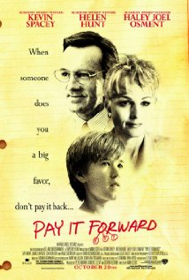
PAY IT FORWARD

SOME KEY ISSUES
The risk, and the costly nature of reaching out to another human being – many of the characters who encounter "pay it forward", in turn, make a response that requires both commitment and courage.
The transforming effect of acts of kindness and generosity – "pay it forward" offers a different perspective on life than the individualistic thrust of modern society.
The potential for every person to make a difference – Trevor thought "pay it forward" had failed, yet many people had benefited from his actions.
CLIPS AND IDEAS FOR RESPONDING

Clip 1
Show the opening section of film up to and including the altercation between Trevor and his mother following her discovery of Jerry, the homeless "guest".
Brainstorm and group discussion
Gather some immediate responses. Write these on a large piece of paper and discuss the issues raised.

Small group activity
Split into three small groups, with each group attempting to stand in the shoes of one of the characters, i.e. Trevor, his mother (Arlene) and Jerry. Try and identify all the thoughts and feelings you experienced in the events portrayed. Share the results of your discussion with the whole group.

Clip 2
Show the section from where Chris (the reporter) meets Trevor's alcoholic grandmother in the midst of the homeless community up to the end of the film.
Group discussion
Trevor made the ultimate sacrifice. Can you think of any times where an act of generosity has been costly to you, or to someone that you know? Is there always a price to pay?

In the Gospels, Jesus often speaks of the costliness of doing God's will, with his own journey to the cross providing the ultimate example. What are the practical implications of Jesus' words and actions for your own daily life?
Small group discussion
There is an old saying: "It is better to light a candle than curse the darkness". The film shows the power of one small person to make a difference. There are echoes here with the Christian story in which a small, unlikely band of Jesus' followers turned the world upside down. Have you ever felt that your own acts of kindness are insignificant? What encouragement can you draw from the film?

What acts of kindness have you experienced which we might be able to use ourselves?

Some useful biblical passages in relation to the film
Matthew 25.31–46 (serving Christ in reaching out to others); John 15.12–14 (the costly nature of love); 1 John 4.7–21 (the Christian imperative to love one

