FAB Club 2012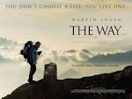

Life is too big to walk it alone......

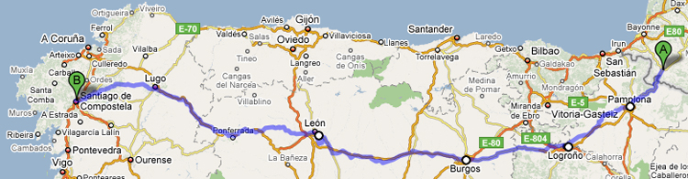

Were you listening??
- What is the real life relationship between Martin Sheen and Emilio Estevez?
- What is The Camino de Santiago or the Way of St. James?
- What is a compostela?

On The Way
Through a series of ongoing conversations between Emilio and Martin, the two decided to create a tribute to Spain to rediscover the land where the Estevez family was rooted. The Camino de Santiago served as the perfect partner in their efforts. And while Spain serves as the backdrop, the film’s primary theme of self-discovery belongs to everyone from all ages and backgrounds, as does the Camino, which has helped transform the lives of millions of pilgrims for centuries.
In the film, a father unfortunately comes to understand his son’s life through his death and along the road finds himself as well. The main protagonist of the film is the conflict we each have within ourselves of choosing a life versus living a life. This greater question of finding oneself is a matter of acceptance and choice. Given the circumstances of our lives, how do we understand ourselves, our family and our friends, and the choices we make? Do we blindly go through life unaware of our actions and how they affect not only ourselves but others, as well? What role does our community, friendships and faith play in our decisions?
The Camino, by its nature, serves as the ultimate metaphor for life. Footsteps along a well-trodden path may be our guide, but do not shield us from the questions that most of our busy everyday lives prevent us at times from fully recognizing. The road offers very little to hide behind. The process of life is life along whichever road, path, Camino, or Way we find ourselves on. Our humanity toward ourselves and others, our history and our future is what defines us. Take the journey of life. Buen Camino!

